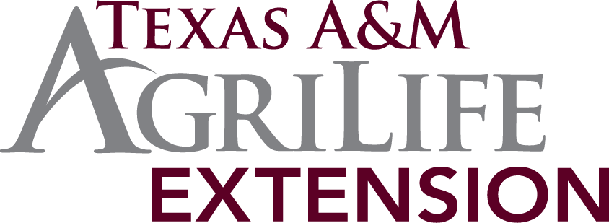

Program Briefing Report Form

- Date program interpretation event was held.

- Name(s) of faculty and/or key leaders conducting program interpretation event:

- Name of legislator and/or staff members attending event:

- List key comments made by legislator and/or staff members. Emphasis needs to be given to any concerns, questions, and/or points of interest shared during the meeting:

- List any additional information or follow-up that is expected by the legislator. If a member of administration need to follow-up, please be sure to identify the appropriate person to contact:

- Other comments relevant to the program interpretation event:

Upon completion of interpretation events, submit report to DEA.

